Keep text together
You can often improve the look of your document by keeping certain words and paragraphs together on the page or across page breaks. Also, you can use hyphenation to improve overall readability.
Word automatically breaks the text at a space or a hyphen at the end of a line. To keep two words or a hyphenated word together on one line, you can use a nonbreaking space or nonbreaking hyphen instead of a regular space or hyphen.
- Click where you want to insert the nonbreaking space.
- On the Insert tab, in the Symbols group, click Symbol.
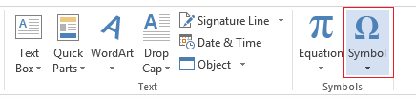
- In the box that opens, click More Symbols.
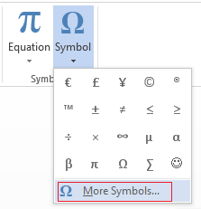
- In the Symbol dialog box, on the Special Characters tab, click the Nonbreaking Space row to highlight it, and then click Insert.
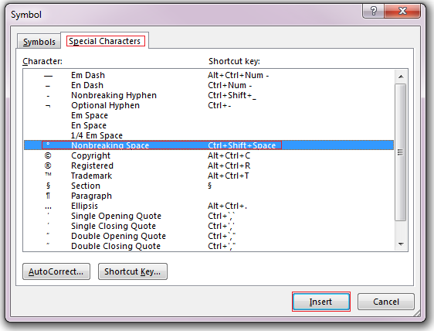
- Click Close.
Tip: You can also use the keyboard shortcut. Click where you want to insert the nonbreaking space, and press Ctrl+Shift+Spacebar.
Sometimes you want a hyphenated word to stay together on one line, without it breaking across lines.
- Click where you want to insert the nonbreaking hyphen.
- On the Insert tab, in the Symbols group, click Symbol.

- In the box that opens, click More Symbols.

- In the Symbol dialog box, on the Special Characters tab, click the Nonbreaking Hyphen row to highlight it, and then click Insert.
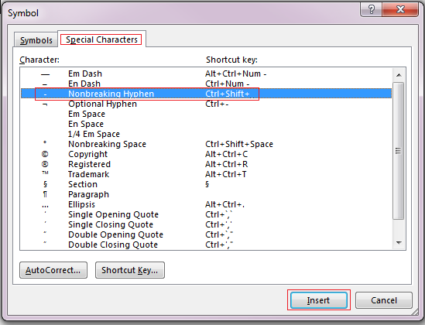
- Click Close.
Tip: You can also use the keyboard shortcut. Click where you want to insert the nonbreaking hyphen, and press Ctrl+Shift+Minus Sign.
Word automatically breaks paragraphs at the end of a page, so a paragraph that started on one page continues on to the next page. To keep the whole paragraph on the same page, follow these steps.
- Right-click the paragraph that you want to keep together. In the box that opens, select Paragraph.
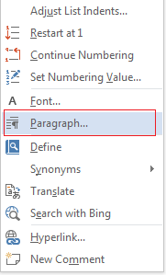
- In the Paragraph dialog box, click the Line and Page Breaks tab.
- In the Pagination section, select the Keep lines together check box, and click OK.
If two consecutive paragraphs or a subhead and a paragraph are closely related, you might want to keep them on the same page.
- Right-click the paragraph or subhead that you want to keep with the content that follows it. In the box that opens, select Paragraph.

- In the Paragraph dialog box, click the Line and Page Breaks tab.
- In the Pagination section, select the Keep lines together check box, and click OK.
Tip: It’s best not to add additional line breaks between your paragraphs because Word interprets each line break as a beginning of a new paragraph, and page breaks might not occur properly. If you want spaces between paragraphs, use the Paragraph Spacing controls. For more information, see Change spacing between paragraphs.
If a paragraph has a page break in the middle so that only the last line appears at the top of the following page, this lonely line is called a “widow.” If, on the other hand, a paragraph has a page break in the middle so that only the first line appears at the bottom of a page while the rest of the paragraph appears on the next page, this lonely line is called an “orphan.”
If you want to avoid widow and orphan lines in your document, follow these steps.
- Right-click the paragraph in which you want to avoid widows and orphans. In the box that opens, select Paragraph.
- Click the Line and page breaks tab.
- In the Pagination section, select the Widow/Orphan control check box.
- Click OK.

